**ACM-ASC Internship 2024**

**Milestone III**

______________________________________________________________________________________________________

**TAG 3 : AI and Disabilities Studies**

**Group ID: DIS07**

**Project Mentor: Dr. Namitha K**

**Project Lead: Girish S**

**Title: AI for Neurodiversity**

**Team Members**

| Girish S | AM.EN.U4AIE22044 |
| --- | --- |
| Anuvind MP | AM.EN.U4AIE22010 |
| R S Harish Kumar | AM.EN.U4AIE22042 |
| Harishankar Binu Nair | AM.EN.U4AIE22023 |

______________________________________________________________________________________________________

**Research Problem**

The current methods for diagnosing Autism Spectrum Disorder (ASD) are heavily reliant on subjective observation, leading to delays in diagnosis and subsequent interventions.

Furthermore, the intricate nature of ASD symptoms complicates accurate identification, increasing the challenges faced by doctors and nurses. This problem underscores the pressing need for novel approaches that surpass the limitations of conventional methods.

By using new technologies like computer vision and deep learning, the process can be made faster and more accurate. Ultimately, this research aspires to reduce the constraints of traditional diagnostic methodologies, fostering improved outcomes for individuals with ASD and the doctors. Through the development and deployment of ASD detection modal, doctors are able to access deep learning tools that facilitate early intervention and personalized care, thereby impacting those affected by ASD with better care.

**Hypothesis**

Our research focuses on improving the accuracy and efficiency of diagnosing Autism Spectrum Disorder (ASD). Current methods for diagnosing ASD rely heavily on subjective observation, leading to delays in diagnosis and intervention. Additionally, the complexity of ASD symptoms makes it challenging to identify the condition accurately. Our goal is to develop innovative technologies, such as computer vision and machine learning, to create automated ASD detection systems. These systems can provide more accurate and timely diagnosis, ultimately leading to better outcomes for individuals with ASD and their families. Another significant outcome of this research is the empowerment of healthcare professionals with advanced diagnostic tools. By equipping specialists with automated ASD detection systems, this research aims to enhance their diagnostic capabilities and support decision-making processes. Additionally, these tools can serve as valuable aids in ongoing monitoring and assessment, enabling doctors to track progress and adjust interventions accordingly.

**Problem definition**

The current diagnostic procedures for Autism Spectrum Disorder (ASD) rely predominantly on subjective observation, resulting in significant delays in diagnosis and intervention, and presenting challenges for accurate identification due to the intricate nature of ASD symptoms. This reliance on subjective assessment places a heavy burden on healthcare professionals, particularly doctors and nurses, and underscores the urgent need for alternative approaches that can overcome the limitations of conventional methods.

In response to this pressing issue, this research aims to investigate novel methodologies that leverage emerging technologies, such as computer vision and deep learning, to revolutionize the ASD diagnostic landscape. By exploring the feasibility and efficacy of these innovative approaches, this work seeks to develop and implement ASD detection modalities that can streamline the diagnostic process, enhance accuracy, and alleviate the burden on healthcare professionals. Ultimately, the research endeavors to empower healthcare providers with advanced diagnostic tools that enable early intervention and personalized care, thereby improving outcomes for individuals with ASD and enhancing their overall quality of life.

**Solution Approach**

The solution approach involves the utilization of multi-modal fusion networks for diagnosing Autism Spectrum Disorder (ASD). Initially, datasets are acquired from online repositories, comprising video recordings, skeletal data, and eye-tracking datasets, each offering distinct insights into ASD-related behaviors. Following data acquisition, preprocessing and feature extraction from these datasets are done. Subsequently, this work proposes a fusion network architecture to integrate the final output from individual models using a fusion layer.

During the training phase, the network learns to effectively merge information from different modalities by combining the outputs from various models. Techniques such as joint optimization, where the network optimizes all modalities simultaneously to improve overall performance, and multi-task learning, where the network learns to perform multiple tasks simultaneously using shared representations, may be employed to ensure that the network can leverage the complementary information from each modality. Additionally, attention mechanisms may be incorporated to dynamically adjust the importance of different modalities based on the input data.

Upon completion of the training process, the multi-modal fusion network generates a final prediction or diagnosis based on the fused information. By combining insights from diverse data sources through a fusion layer, the network offers a more comprehensive understanding of ASD-related behaviors, leading to more precise and robust diagnoses. This approach facilitates early detection and intervention, ultimately improving outcomes for individuals with ASD.

**Research Contribution**

Multi-Modal Fusion Network combines various types of information, such as Gait Data, Gaze data, Skeletal Data, to enhance the understanding of autism. By integrating these diverse datasets, a more comprehensive understanding of autism-related behaviors is achieved. Deep Learning Techniques are utilized to extract key insights from the data, enabling a deeper analysis of autism symptoms.

This approach improves the accuracy and reliability of autism diagnosis. It broadens the scope of observation for doctors and researchers, allowing them to consider a wider range of factors when assessing individuals. By gaining a better understanding of autism behaviors, this method lays the groundwork for more effective interventions and support strategies.

In summary, this work advances autism research and treatment by introducing an innovative approach through data analysis. Through the strategic integration of diverse datasets, this offers a valuable tool for healthcare professionals and researchers to gain deeper insights into autism spectrum disorders and provide better support for individuals affected by ASD.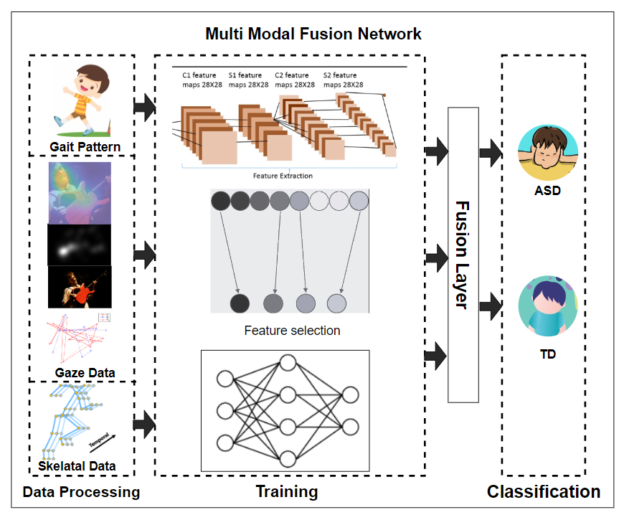  
**Block Diagram**